First day of school

SUMMARY
Students are challenged to create a maze track, answering some “get to know you” questions, using Ozobot with OzoCodes.
OVERVIEW

Critical thinking
Planning
Computational thinking
Creative thinking

This lesson tasks students to create and modify a maze template, answering questions in assigned places, then making sure the Ozobot goes through the answers in order.
It will have a start and an end point.

LESSON OUTLINE
Paperless
- Students will be given access to a Google Slides
- Students will answer the get to know you questions in the assigned spaces, in the order they choose
- Students complete the maze using lines and OzoCodes to make sure the Ozobot goes through the answers in order.
- They present the Slides presentation, and place the Ozobot on top of their screen to see their work.
Traditional
- Students will be shown a maze template
- Students will answer the get to know you questions in the assigned spaces, in the order they choose.
- Students complete the maze using lines and OzoCodes with Ozobot markers, to make sure the Ozobot goes through the answers in order.
PREREQUISITES
Paperless.
Experience drawing lines and OzoCodes for Ozobot, coping from OzoCodes bank provided in the Google Slides presentation.

Traditional
Experience drawing lines and OzoCodes for Ozobot with markers.

GRADE LEVEL
K to 9

GROUPING
Individuals or small groups

MATERIALS
Paperless
- iPads
- Ozobot Bit or Evo per group
Traditional
- Markers, 1 set per student
- Blank paper and pencils
- Ozobot Bit or Evo per group

DURATION
45 minutes
LESSON

- Test the different OzoCodes
- Create a maze making sure to leave enough space to fill with OzoCodes.

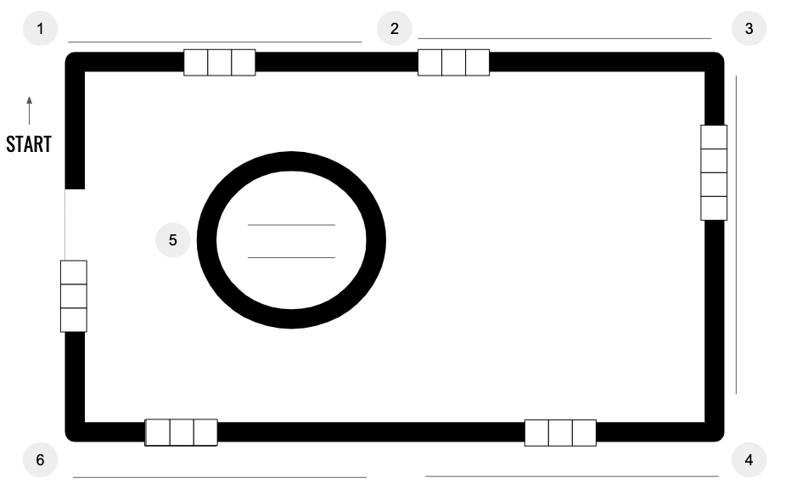

- Answer the following questions:
  - Full name
  - Nickname
  - What do you like best about school?
  - Choose five words to describe yourself.
  - Name two things that make you happy.
  - What are your hobbies?

Test Ozobot on the maze. Does Ozobot get stuck on any thin lines, tight corners, or are lines too close together? Students can draw a second draft to test.

