Lesson Title: SDG Goal #2 Zero Hunger: The A-maze-ing Challenge (Elementary)

Lesson Summary: Students will participate in a school wide fundraiser to collect non-perishable food donations for a local charity, such as a foodbank. With these food donations, in teams (or in classes), students will create a food maze and color code their Ozobots to successfully travel through their maze.

Lesson Objectives
Students will be able describe the Sustainable Development Goals and identify ways they can support SDG #2 Zero Hunger
Students will be able to code their Ozobot using color codes
Students will be able to use work collaboratively and use critical thinking and problem solving skills to create a maze

Subjects: Computer Science, ELA, Social Studies
Pre-Reader/ESL Friendly (no reading skills required): Yes
Coding Style: Color Code
Grades: K-12
Tested with: (Evo/Bit)
Duration: 3-60 Minute Periods

Required Materials:
-non-perishable food items
-Ozobots (number dependent on how many mazes being created)
-Ozobot markers
-OzoCodes Sheet
-rulers
-paper to be used for color coding (long stips of paper cut to fit in maze)
-scissors
-tape
-post it notes
-(optional): poster paper, iMovie (or other video recording technology), or digital presentation to create an awareness campaign about SDG #2 and the local charity the food drive is supporting

Background Knowledge:
-Teacher and students should have some experience color coding Ozobots. See OzoCode Sheet for a reference: OzoCodes Sheet https://files.ozobot.com/stem-education/ozobot-ozocodes-reference.pdf
-Resources to learn more about the Sustainable Development Goals:
UNESCO and Sustainable Development Goals https://en.unesco.org/sustainabledevelopmentgoals
TEACH SDGs - Home http://www.teachsdgs.org/
Videos http://www.teachsdgs.org/videos.html
About the Sustainable Development Goals - United Nations Sustainable Development https://www.un.org/sustainabledevelopment/sustainable-development-goals/
United Nations Sustainable Development Goals Student Resources https://www.un.org/sustainabledevelopment/student-resources/
SDG Book Club - United Nations Sustainable Development https://www.un.org/sustainabledevelopment/sdgbookclub/
The Worlds Largest Lesson http://worldslargestlesson.globalgoals.org/

Resources for SDG Goal 2:
Preview Exemplar Video: SDG #2 Zero Hunger Ozobot Challenge https://www.youtube.com/watch?v=BZ7g1q7xJ8M

ZERO HUNGER: WHY IT MATTERS https://www.un.org/sustainabledevelopment/wp-content/uploads/2018/09/Goal-2.pdf

Goal 2: Zero hunger (undp.org) https://www.undp.org/content/undp/en/home/sustainable-development-goals/goal-2-zero-hunger.html

Goal 2: Zero Hunger (worldslargestlesson) https://worldslargestlesson.globalgoals.org/global-goals/no-hunger/

Lesson Tips:

1.Provide students with the opportunity to explore a variety of mazes. Students can solve maze puzzles and also create their own mazes on graph paper. In small groups, it may also benefit students to color code their own smaller mazes and test out with an Ozobot before completing a larger scale maze.
2.Spend time exploring SDG 2: Zero Hunger. How can this goal be achieved at a local, national, and global level? Students would benefit from exploring some of the resources provided, hosting local experts on this topic, having class discussions, journaling, and creating their own awareness campaigns.
3. Decide how you want to launch the A-Maze-ing Challenge.
-Will it be a school wide initiative? All classes could create one larger scale maze with the food they bring in. Who will create the most a-maze-ing maze?
-Or will just your class work in small groups to create a variety of mazes?
-Allow time to launch the A-Maze-ing challenge. You will need time to collect non-perishable food and explore resources about SDG 2: Zero Hunger (estimated time one month)
4. non-perishable food items should be used to create a stable maze that will not easily collapse and damage the Ozobot

Accommodations and Differentiation:
-pair students who may need extra support with students who demonstrate strong design thinking skills
-provide an already created maze blueprint for students who may need extra support to use as a guide when constructing their maze

Direct Instruction (Teacher Facing Instructions):
Day 1 (60 minutes)
- Tell students that they will be launching a social activism project to bring in food for a local food bank. Watch video #FightHungerTogether Kids Respond to Child Hunger (3 minutes). As suggested in the video, students could share some of their ideas about how to respond to child hunger by writing their ideas on post it notes and displaying them on a large board.
- Share some of the resources (see background knowledge for some possible suggestions) about the Sustainable Development Goals and specifically Goal #2. There are a variety of lessons ideas from the World’s Largest Lesson that will extend student learning of Goal 2: Zero Hunger. For example, (grades 3 +) students could have a class discussion or journal using the prompt below.
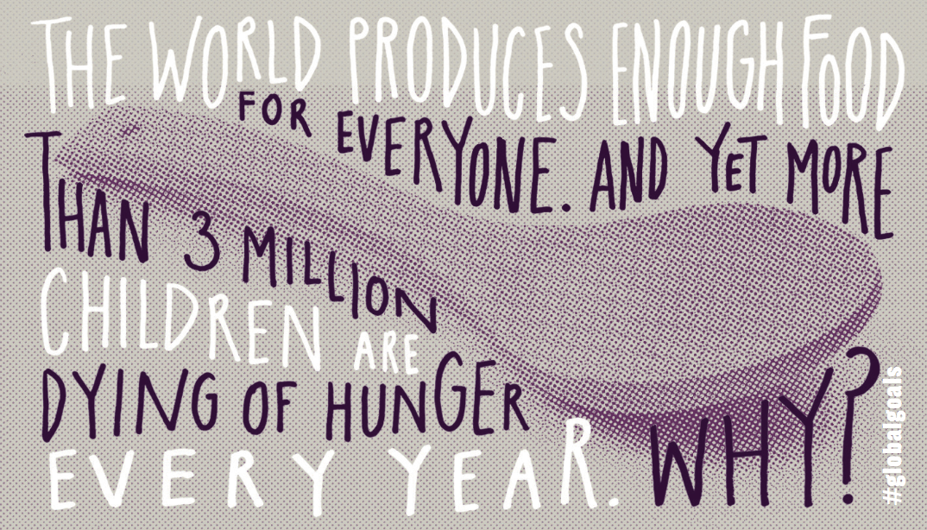
- (optional - additional 60+ minute period): Have students create a poster, iMovie (or other video recording technology), flipgrid, or digital presentation to create an awareness campaign about SDG #2 and the local charity their food drive is supporting.
- Tell students that they will use the non-perishable food they donate to create a maze and then color code an Ozobot to travel through the maze.
- Provide students with examples of maze puzzles to use to help inspire their maze design. Students can also explore Instructables Living: How to Draw a Maze : 9 Steps (with Pictures)

Day 2 (60+ minutes) *note: length of time that is needed is dependent upon amount of non-perishable foods
- In groups, students will create their maze using non-perishable food items. Their maze should have a start and a finish opening. (Print off 2 SDG pdf Zero Hunger to mark start and finish). The maze should also have a variety of dead ends and inner walls. See Ozobot SDG #2 Challenge https://www.youtube.com/watch?v=BZ7g1q7xJ8M for an overview of this project.
- Using strips of paper that are cut to fit into the maze, students will use the Ozocode Sheet to code their Ozobot to successfully navigate through the maze. Alternatively, masking tape could be used to create the maze and Ozocode could be written directly on the tape. All intersections should be color coded in black as this allows Ozobot to randomly travel the maze - will it get out? A win/exit (play again) color code can be placed at the end of the maze.

Day 3 (60+ minutes)
- Share a-maze-ing mazes with the school and larger school community.
- Allow opportunity for students to reflect on how they can continue to work towards the goal of Zero Hunger (see Background Knowledge resources for possible lesson extensions). Class discussion and/or journalling can be a great way to reflect.
- View a Zero Hunger video (possible suggestions):
Share the Global Goals: Zero Hunger Film https://www.youtube.com/watch?v=iteCytv0RqY (2 minutes), 2030- SDG 2- Zero Hunger- Ted talks https://www.youtube.com/watch?v=YLldS3S_AOI
(6 minutes), or Kid President Needs Your Help to Fight Child Hunger https://www.youtube.com/watch?v=Hzpj4M2fBsU (2 minutes)

Student Practice (Student Facing Instructions):

Maze Construction:
After exploring a variety of mazes, start building your own maze using non-perishable food items.
- Make sure your maze has a start and finish opening.
- It should have some dead ends and interesting inner walls.
- Your maze must be stable
- It must have enough room for Ozobot to successfully navigate
- All members of your team should be included in the building of the maze
- Activate your growth mindset, if your maze doesn’t work be sure to keep redesigning it!

Coding the Maze:
Use the OzoCodes Sheet to help you code your Ozobot to successfully navigate the maze.
- With tape, cut and securely arrange the paper between the maze.
- Using the OzoCodes Sheet and Ozobot markers, carefully write down your code instructions. Be careful not to knock over your maze. If it’s easier you can write down the code first and then secure it in your maze.
*Allow all groups members an opportunity to code.
- Test out your Ozobot and make any necessary changes.

Extensions:
- Have students write and submit an article about the A-maze-ing Challenge to the school newsletter or local newspaper.
- Using math skills, older students could determine the perimeter or area of their maze. Younger students could sort and count the non-perishable food items.
- As a challenge, students could color code different maze pathways (only one pathway will lead to the exit). Place an ozobot on each color coded pathway and see which one will successfully complete the maze.
- Use Ozoblockly to complete the Maze Game lesson (created by Linda McClure) Ozobot Lesson Library https://classroom.ozobot.com/lessons/lngUQBRz94QPaqIxIVer63aQ6z Lesson description: Using the OzoBlockly programming language, students program Ozobot Bit to find the treasure on one of the maze handouts. Students compete to see who can get to the treasure. They can be challenged to get there first, using the fewest number of blocks, etc.

Closing (Or Formative/Summative Assessment):
As a lesson closure, students (and perhaps the larger school community) can come together to share and celebrate the a-maze-ing food donation mazes.

Academic Standards:
CSTA 1B-CS-02 Model how computer hardware and software work together as a system to accomplish tasks. (P4.4)

CSTA 1B-CS-03 Determine potential solutions to solve simple hardware and software problems using common troubleshooting strategies. (P6.2)

CSTA 1B-AP-16 Take on varying roles, with teacher guidance, when collaborating with peers during the design, implementation, and review stages of program development. (P2.2)

ISTE 4a Students know and use a deliberate design process for generating ideas, testing theories, creating innovative artifacts or solving authentic problems.

ISTE 4d Students exhibit a tolerance for ambiguity, perseverance and the capacity to work with open-ended problems.

ISTE 6d Students publish or present content that customizes the message and medium for their intended audiences

ISTE 7d Students explore local and global issues and use collaborative technologies to work with others to investigate solutions.

CCSS.ELA-LITERACY.SL.4.1.B Follow agreed-upon rules for discussions and carry out assigned roles.

Additional Attachments:
SDG #2 Print as start and end makers for maze SDG Zero Hunger pdf printable
Instructables Living: How to Draw a Maze
How to Draw a Maze : 9 Steps (with Pictures)
Ozobot Color Codes Reference Sheet
OzoCodes Sheet
SDG #2 Zero Hunger Ozobot Challenge (exemplar video)

